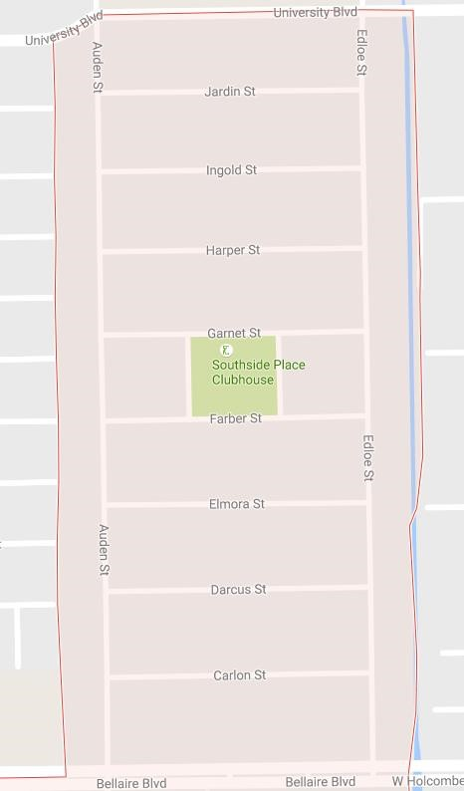
Fire truck
3768 Carlon- Splash Station #4
3744 Ingold -
Splash Station # 1
6610 Auden- Splash Station #3
Auden Water Station
6414 Auden Splash Station #2
Start

Start

Start
End

